EEZ BB3+ wire harness
This is a wire harness for the EEZ BB3+ with two power modules. For an additional module, it is necessary to include one more AC power module cable and one DC power module cable.

Table of contents
- Cooling fan cable
- TFT module FFC cable
- AC power module cable
- DC power module cable

Cooling fan cable
Total length | 70 (± 5) mm
Type | 3 wire, already mounted on the cooling fan
Fan: | TME: MF92251V1-G99-A  LCSC: C55123210  Mouser: 369-MF92251V1100UG99
 | 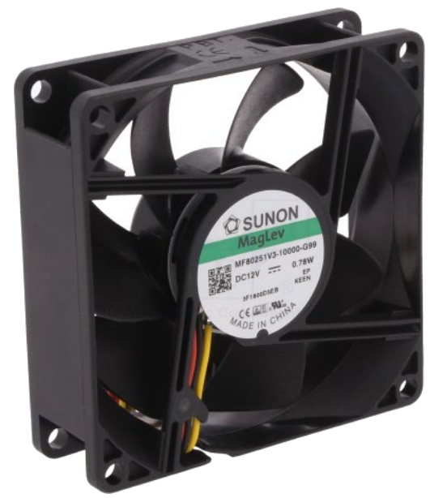
Connectors
Side A | X13 | Side B | N/A
Housing type | Receptacle, 0.1” | Fan is already equipped with cable. Therefore it only has to be terminated with the connector on side A.
TME | MX-22-01-3037
LCSC | C185238
Mouser | 538-22-01-3037
 | 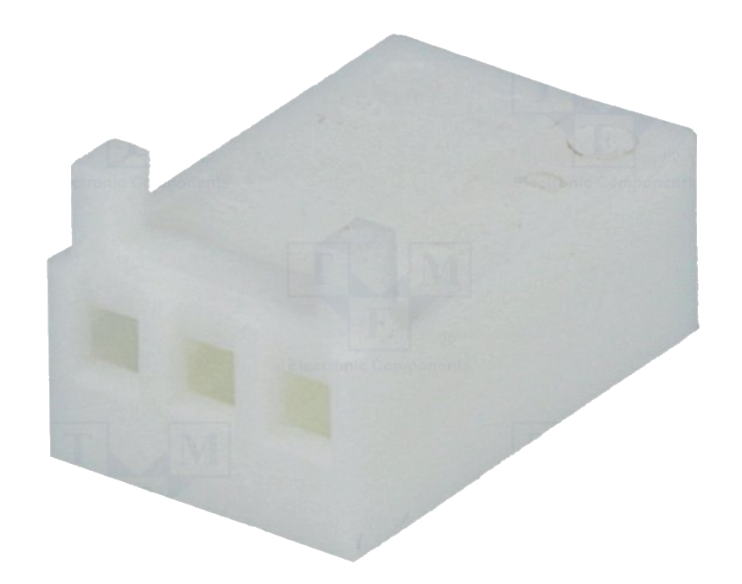
Pin | Female
Pin quantity | 3
TME | MX-0850-0114
LCSC | C45408619
Mouser | 538-08-50-0114
 | 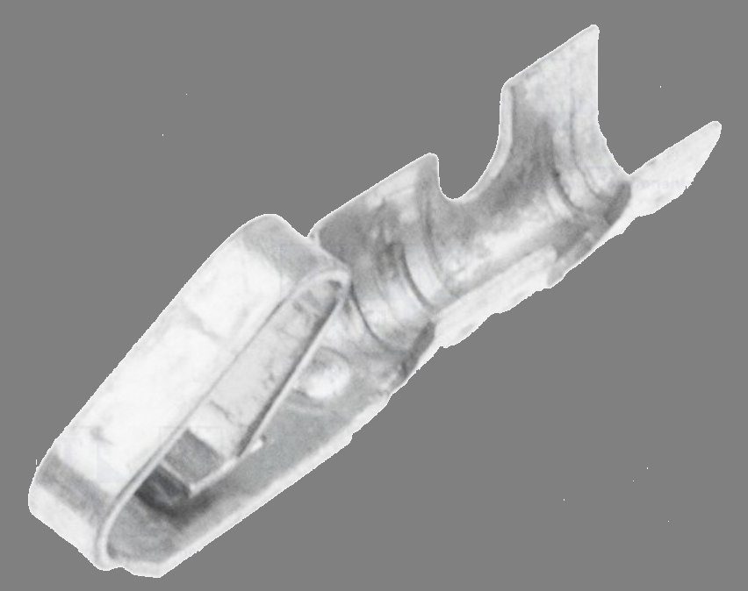

Wiring

Name | Position | Color / description
GND | 1 | Black
+12 Vdc | 2 | Red
Tacho | 3 | Yellow

Picture

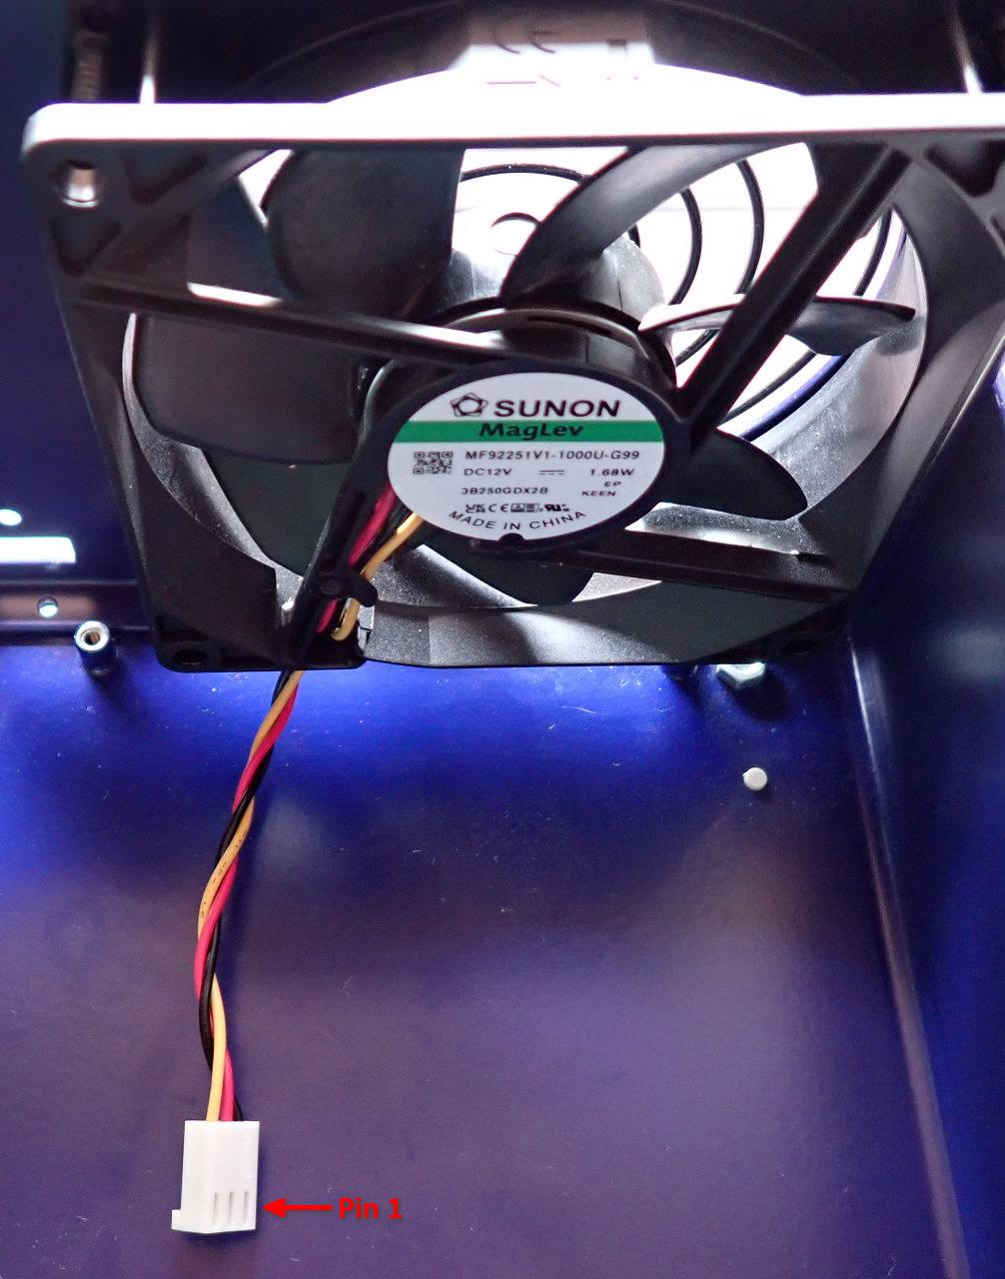

TFT module FFC cable
Length | 101 mm, 0.5 mm pitch, 22 pin
Type | Assembled ribbon cable with IDC connectors; 16x28AWG
TME | 05-22-A-0101-A
LCSC | C18024481
Mouser | 640-522A0101A4064T

Picture

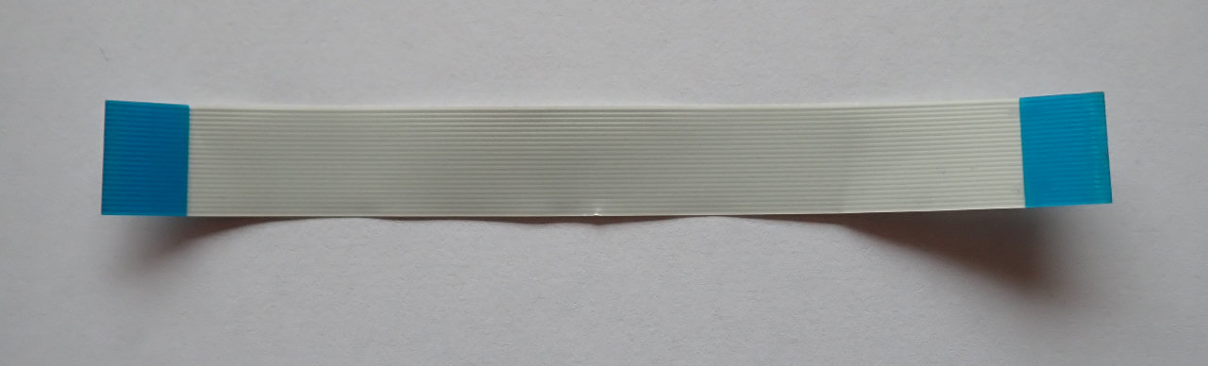

AC power module cable
Length | 200 (± 5) mm
Type | 0.75 mm² (18 AWG) single wire, stranded, min. 250 VAC
TME | Brown: H05VK075BR, Blue: H05VK075BL, Green-Yellow: H05VK075GN/GE
LCSC | –
Mouser | Brown: 602-3055-100-07, Blue: 602-3055-100-06, Green-yellow: 602-3055-100-28
Connectors
Side A | Mainboard (X10, X11 or X12) | Side B | AC/DC module power output
Housing type | Female, wire-to-board connector, 3.96 mm pitch | Housing type | Female, wire-to-board connector, 3.96 mm pitch
TME | VHR-3N | TME | VHR-3N
LCSC | C157899 | LCSC | C157899
Mouser | 306-VHR-3N | Mouser | 306-VHR-3N
 | 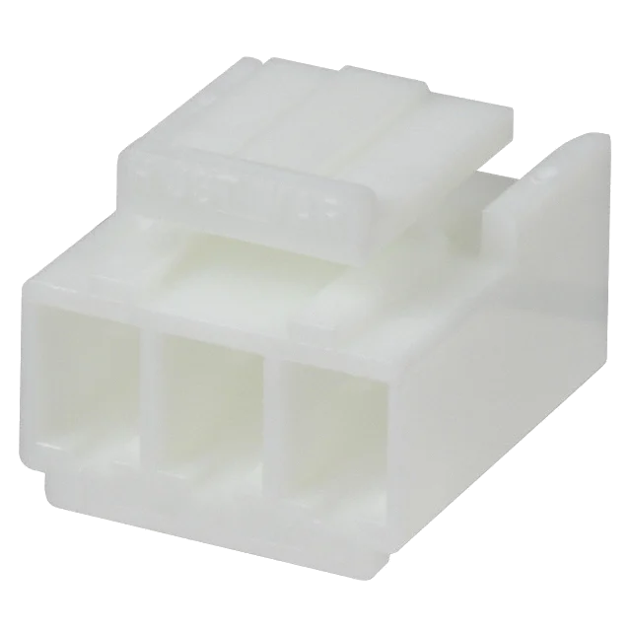
Pin | Female | Pin | Female
 | 3 | Pin quantity | 2 (middle position is not populated!)
TME | NS39-T | TME | NS39-T
LCSC | C160349 | LCSC | C160349
Mouser | 306-SVH-21T-P1.1 | Mouser | 306-SVH-21T-P1.1
 | 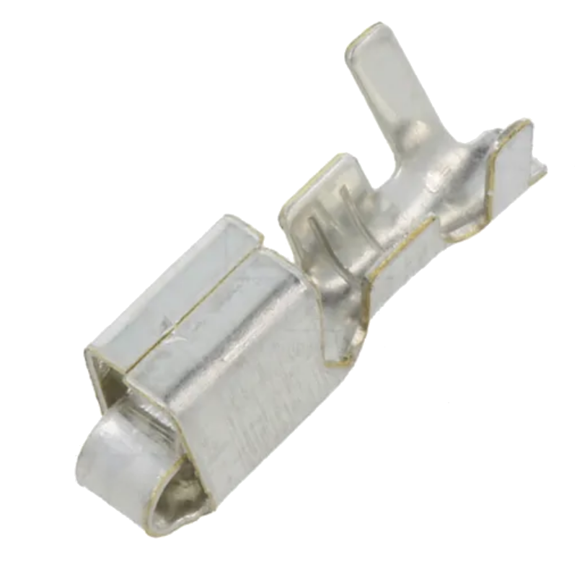
 |  | Insulated ring crimp terminal | Ring inside diameter 3.2 mm
 |  | TME | –
 |  | LCSC | C20232480
 |  | Mouser | 548-BU-190540035
 |  |  | 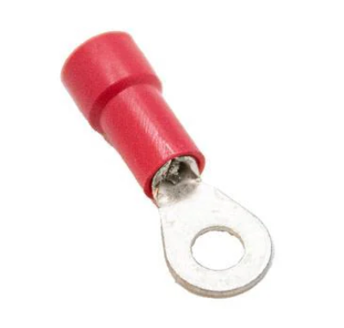

Picture

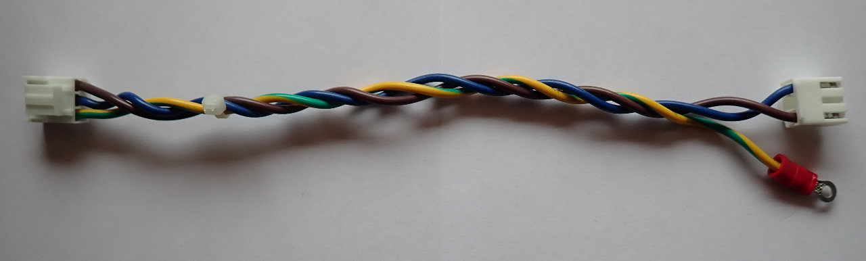

DC power module cable
Length | 370 (± 5) mm
Type | 0.75 mm² (18 AWG) single wire, stranded, min. 250 VAC
TME | Red: H05VK075RT, Black: H05VK075SW
LCSC | –
Mouser | Red: 602-3055-100-03, Black: 602-3055-100-02
Connectors
Side A | Power module (X3) | Side B | AC/DC module power output
Housing type | Female, wire-to-board connector, 3.96 mm pitch | Housing type | Female, wire-to-board connector, 3.96 mm pitch
TME | VHR-4N | TME | VHR-4N
LCSC | C157898 | LCSC | C157898
Mouser | 306-VHR-4N | Mouser | 306-VHR-4N
 | 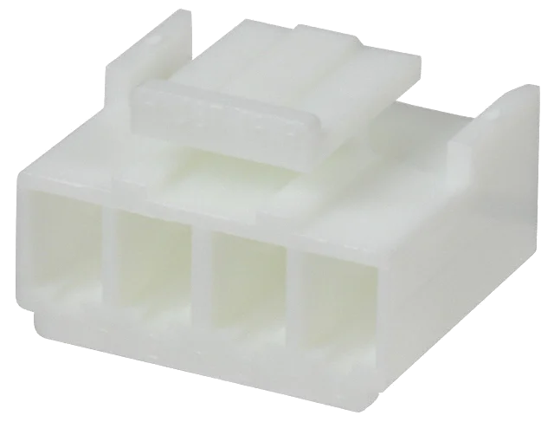
Pin | Female | Pin | Female
Pin quantity | 2 | Pin quantity | 2
TME | NS39-T | TME | NS39-T
LCSC | C160349 | LCSC | C160349
Mouser | 306-SVH-21T-P1.1 | Mouser | 306-SVH-21T-P1.1

Picture

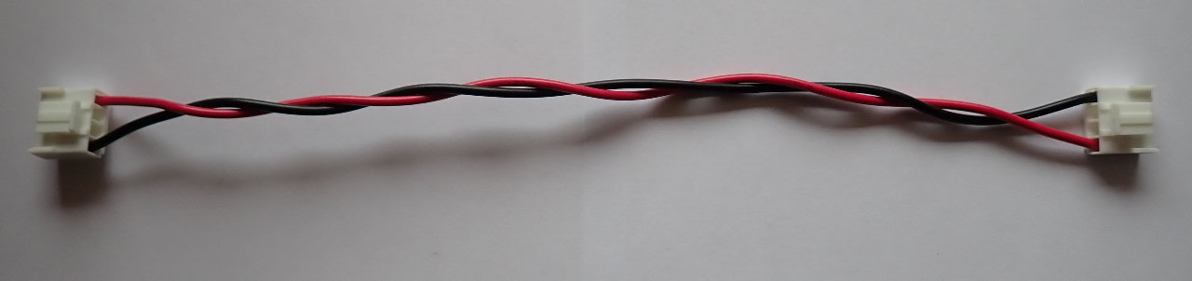
View of the AC/DC module mounted on the BB3+ top plate, with cables for the power module connected:

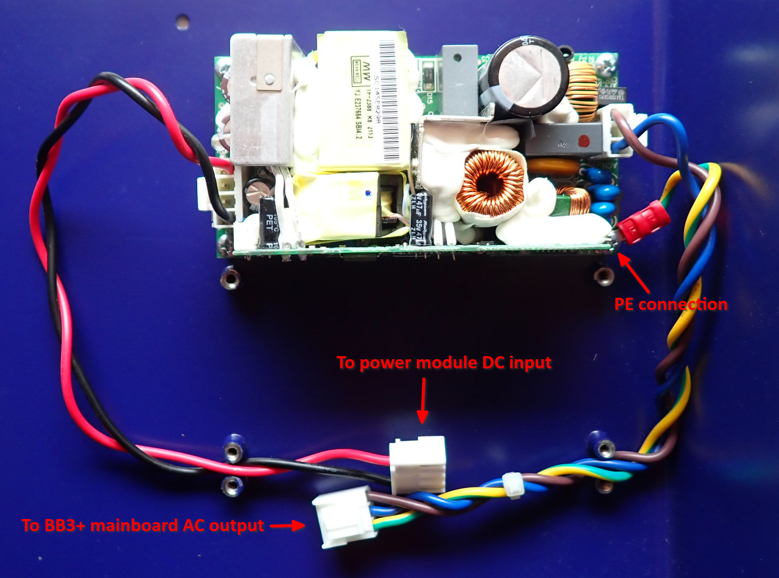

BOM
The following BOM includes items for connecting two power modules.

Type | Part (TME) | Part (LCSC) | Part (Mouser) | Total
3-pin 0.1” receptacle | MX-22-01-3037 | C185238 | 538-22-01-3037 | 1
0.1” pin | MX-0850-0114 | C45408619 | 538-08-50-0114 | 3
TFT module FFC cable | 05-22-A-0101-A | C18024481 | 640-522A0101A4064T | 1
3-pin header 3.96 mm | VHR-3N | C157899 | 306-VHR-3N | 4
4-pin header 3.96 mm | VHR-4N | C157898 | 306-VHR-4N | 4
3.96 mm pin | NS39-T | C160349 | 306-SVH-21T-P1.1 | 18
Ring crimp terminal | – | C20232480 | 548-BU-190540035 | 2
0.75 cm² wire (Brown) | H05VK075BR | – | 602-3055-100-07 | 0.4 m
0.75 cm² wire (Blue) | H05VK075BL | – | 602-3055-100-06 | 0.4 m
0.75 cm² wire (Red) | H05VK075RT | – | 602-3055-100-03 | 0.74 m
0.75 cm² wire (Black) | H05VK075SW | – | 602-3055-100-02 | 0.74 m
0.75 cm² wire (Yellow-Green) | H05VK075GN/GE | – | 602-3055-100-28 | 0.4 m
12 Vdc cooling fan | MF80251V3-1000U-G99 | – | – | 1
Polyamide cable tie; L: 100 mm; W: 2.5 mm | BMB1025 | – | – | 4

